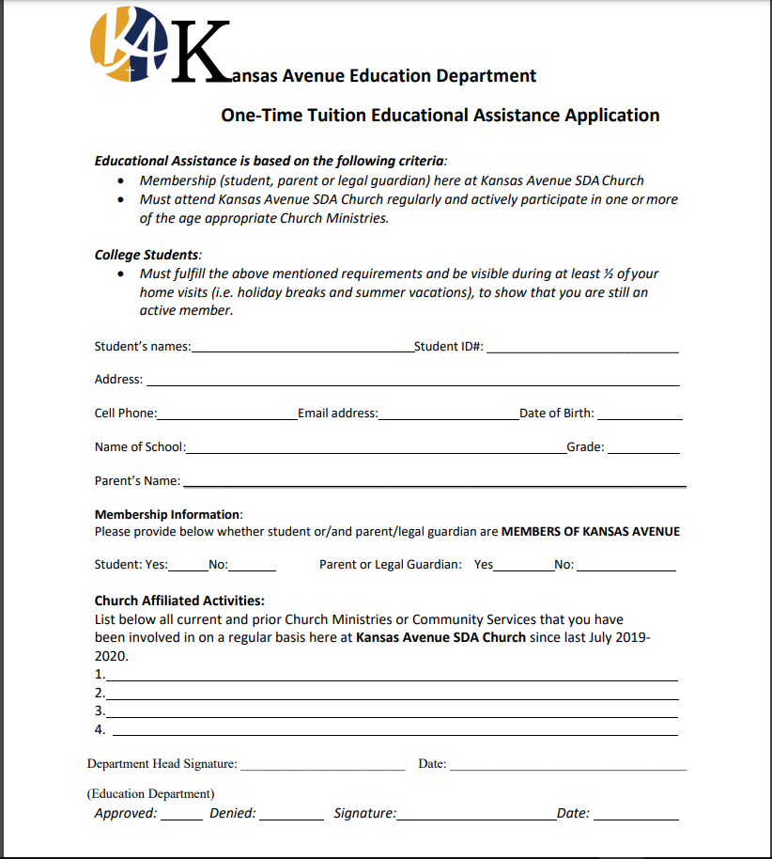

**July 2021 -**

**July 2022**